gRNA design for a gene knock-out
1. Select a target sequence where to design your gRNA:
- For genetic knockouts, gRNAs commonly target 5′ constitutively expressed exons, which reduces the chances that the targeted region is removed from the mRNA due to alternative splicing.
- As a rule of thumb, avoid target sites that code for amino acids near the N’ terminus of the protein, in order to mitigate the ability of the cell to use an alternative ATG downstream of the annotated start codon. Likewise, avoid target sites that code for amino acids close to the C’ terminus of the protein to maximize the chances of creating a non-functional allele. For a 1 kilobase gene, since potential target sites occur ~1 in every 8 nucleotides, restricting gRNAs to 5 – 65% of the protein coding region will still result in many dozens of gRNAs to choose from. With so many possibilities, picking a gRNA with an optimized sequence is of primary importance.
- If possible, design gRNAs to target exons that code for known essential protein domains. The benefit of this approach is that even non-frameshift alleles may alter protein function when they occur in important protein domains.
(Source: Addgene; https://blog.addgene.org/how-to-design-your-grna-for-crispr-genome-editing ; https://www.addgene.org/guides/crispr/)

2. Take note of the gene Ensembl code (example for PDPR: Ensembl:ENSG00000090857), and note the transcript information (example for PDPR: Transcript NM_017990; ENST00000288050.9 PDPR-201, Human CCDS set: CCDS45520)
3. Log into Benchling (or create a new account (free)): https://benchling.com/signin/welcome
  - Creating a project folder and importing the sequence using Benchling

    - Create project folder by choosing “+” next to “Projects” (or use an already existing project). Name the project and choose parameters in “manage collaborators” as you will.
    - Once you are in the project folder, import the sequence of the target gene by choosing “+” on the left panel. Then choose “DNA Sequence” -> “import DNA sequence” -> “search external databases”
In the search bar, enter the Ensembl code (ex: ENSG00000090857). Select the genome database of your choice. Note: for human genes, the CRCh38(hg38, Homo Sapiens) genome database works well. In the transcript section, select the chosen transcript from the information noted in step 2 (ex: PDPR-001 (ENST00000288050, CCDS45520). Import the sequence in your folder.
If you already have the DNA sequence in your computer, you can also just click on “new DNA sequence” and copy-paste or import a sequence file from your computer.
  - Designing a gRNA in Benchling

    - Open the “split workspace” tab (located on the right down corner).
    - Go to the exon of interest and make sure it is selected/highlighted.
    - Click on the CRISPR tool (located on the right: this icon: ) and click “DESIGN AND ANALYZE GUIDES”.
Select the following guide parameters: Design type: single guide, length: 20, genome: the same used for importing the DNA sequence, PAM: NGG (SpCas9, 3’ side). Click “Finish”. Check that the target region corresponds to the targeted exon and click “+” (create).
    - The program generates a list of proposed guides. You can sort them by On-Target or Off-Target Scores. Select the guide which has the highest combination of On-Target and Off-Target scores and save it to the folder of the project.
    - A new DNA file corresponding to the gRNA will automatically be created in your project folder. The gRNA will also appear on the map of your original DNA file, showing where it is targeting.

4. Create complementary oligo and add overhangs
The gRNA that was just created corresponds to the target sequence.
4.1 Create the complementary oligo by using the following website (or similar tool): https://www.bioinformatics.org/sms/rev_comp.html
Paste the gRNA sequence under >Sample sequence in the text area like shown below, and press submit to obtain the complementary oligo.
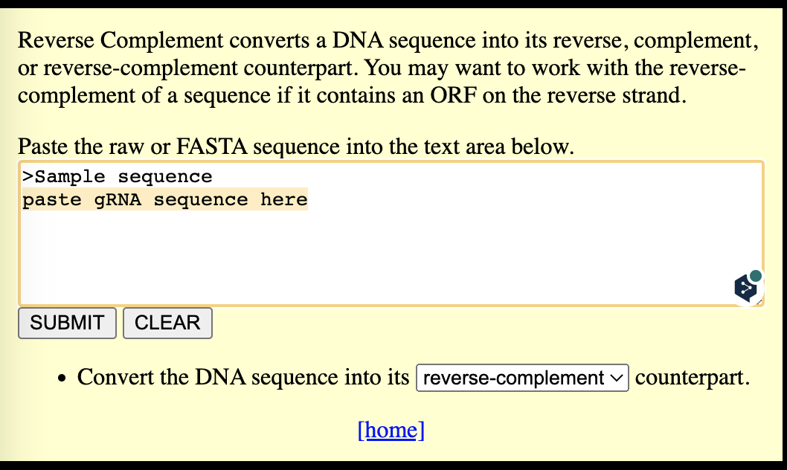

Finalize the creation of the oligos by adding the following overhangs:
For Forward oligo: 5’ CACCG-------- 3’
For Reverse oligo: 5’ AAAC--------C 3’

Here is a more detailed description with an example:
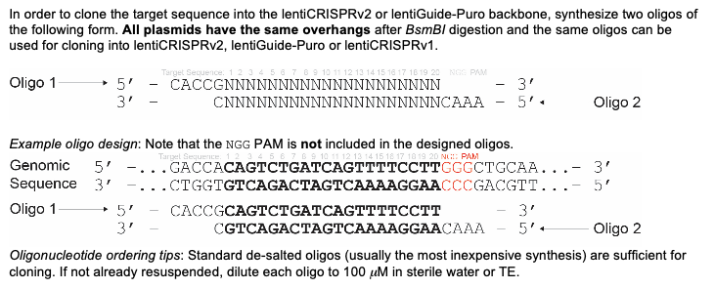
4. Order the oligos
Order the oligos with the following synthesis parameters:
- Synthesis scale: 0.01 µmol minimum
- Purification: desalted
- Format: liquid
- Concentration: adjusted to 100 µM (H2O)

References:
Improved lentiviral vectors and genome-wide libraries for CRISPR screening. Sanjana NE*, Shalem O*,
Zhang F. Nature Methods (2014).
Genome-scale CRISPR-Cas9 knockout screening in human cells. Shalem O*, Sanjana NE*, Hartenian E, Shi X, Scott DA, Mikkelsen T, Heckl D, Ebert BL, Root DE, Doench JG, Zhang F (2014). Science, 343, 83-7. DOI: 10.1126/science.1247005

